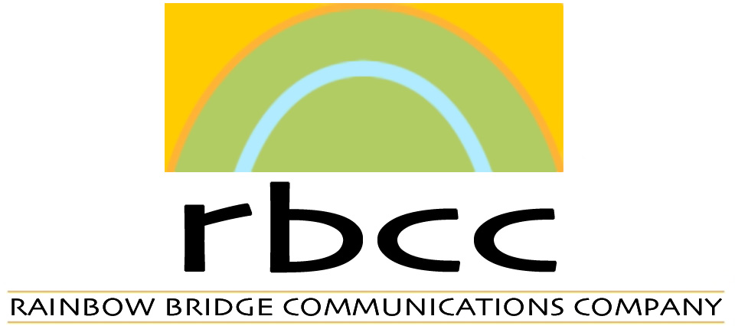

Video project ideas for SESCI-NAC for the 2008/2009 production season. This list was written by Barb Allard and is copyright Barb Allard August 2008. Any questions: phone 780-455-6465.

“Eco-buildings”
- Riverdale NetZero, (interviews already shot with Gordon Howell and Peter Amerongen of Riverdale NetZero)
- A series on eco-homes in and around Alberta, with various unique features, some old and some new. I would be looking for the best of the best, including passive solar, solar PV, solar thermal, as well as super-efficient designs, water capture, low-water gardening, non-toxic materials.
- Build Green, R2000 and other building standards. What does it take to get the bar raised?
“The Grid”
- What is the potential of total distributed generation in Alberta: solar PV, wind, hydro, co-generation, bio-mass (other?)?
- What do we need to do to our grid (if anything) in order to take full advantage of potential DG in Alberta? Potential designs/re-designs? District electricity systems? What is being planned?
- The story of our grid, past, present, future.
- The story of micro-power and net-metering, and are there any incentives coming up in Alberta?
“Staying Warm”
- “Passive Solar” (already in production)
- What is lining up to replace conventional natural gas for heating buildings in Alberta besides coal gasification and coal-bed methane? A switch to electricity or the potential of building district heating systems using solar thermal, geothermal and waste heat.
“Solar Society”
- Are the Municipal Solar Showcase, Eco-solar Home Tour and other demonstration projects helping to raise the profile of solar energy in Alberta?
- Which new housing developments are beginning to utilize solar energy?
- How did Germany create their widespread commercialization of solar PV? How about solar thermal in Spain and other countries, as compared to Canada and the US?
- An overview of the various ways to use solar energy, and what is the potential is to maximize this?
SESCI-NAC
- I could also do a series of profiles of SESCI members, small businesses and innovators and the pioneering work that is being done.

